**Stage 1 – This isn’t going to have a happy ending**

**DESIGNER:** Ike Starnes

|  |
| --- |
| **SCORING:** Comstock 28 rounds.  **TARGETS:** 14 cardboard targets  **SCORED HITS:** 2 Best hits per carboard will be scored. |

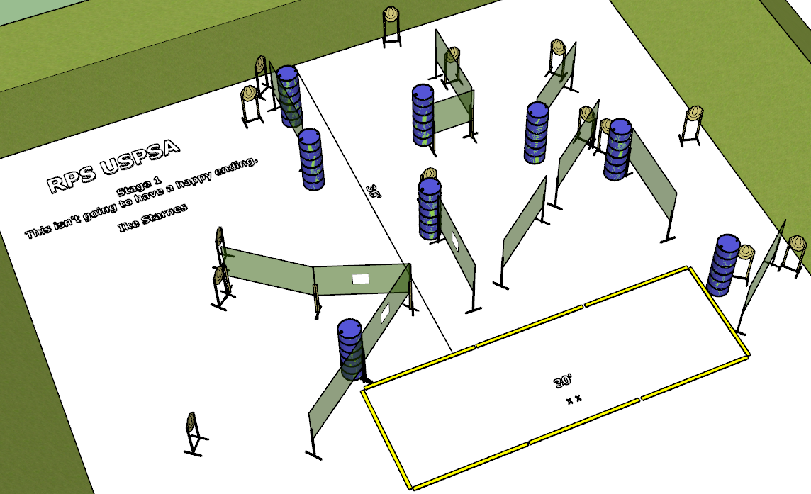

**Written Stage Briefing:**

**Stage 1 - This isn’t going to have a happy ending -** is a 28 round, 140 point, comstock course. There are 14 cardboard targets. The best 2 hits per cardboard target will be scored.

**Start position** Both feet on the Shooting Sports Innovations Xs, facing generally downrange.

**Handgun: Loaded and holstered with wrists below belt.**

**PCC: Loaded held in both hands, stock touching belt.**

On the audible start signal, engage targets from within the shooting area.

**USPSA / NROI Range Commands:**

* Make Ready
* Are you ready?
* Standby
* If finished, unload and show clear.
* If clear, hammer down and holster
* Range is clear

**Setup Notes:**

18 Single Wall Stands

4 Double Wall Stands

9 Full Walls

3 Port Walls

1 Half Wall

14 Target stands / 28 target sticks

1 Starting Xs

16+ barrels